Tiedotepohja julkisen hallinnon organisaatioiden käyttöön:
Transition to digital official mail:
An electronic mailbox will be activated for you when you identify yourself in an authority’s e-service
Official mail is becoming primarily digital. As of 14 April 2026, when you identify yourself in [enter your organisation or e-service name here] or another authority’s electronic service for the first time, you will be directed to activate Suomi.fi Messages. From then on, that is where you will receive mail from several public authorities. Suomi.fi Messages will replace official paper mail: you will not receive letters about the same matter later.
Starting in mid-April 2026, you will be directed to activate Suomi.fi Messages during identification if you are not already using the service. The activation will require you to take measures and will not happen without you noticing.
How and for whom will Suomi.fi Messages be activated?
- Suomi.fi Messages will activate for you if you are an adult and have not yet activated the service.
- You will be directed to activate Suomi.fi Messages when you use Suomi.fi e-Identification for strong identification in a public administration e-service.
- Enter your email address upon activation and verify it. This way, you will always receive an email notification when you receive new mail in Suomi.fi Messages.
- After you have entered your email address, you can continue to identify normally and move to the e-service you were about to use.
- Please note that if you are acting on behalf of an organisation or another person, Suomi.fi Messages will be activated for you personally – not the person or organisation you are acting on behalf of.
If you do not use the e-services of public administration, the change will not affect you, and you will continue to receive paper mail from authorities.
The change also does not apply to minors, persons under guardianship or persons with a valid continuing power of attorney.
This is how you will be directed to activate Suomi.fi Messages when you identify yourself in public administration e-services.

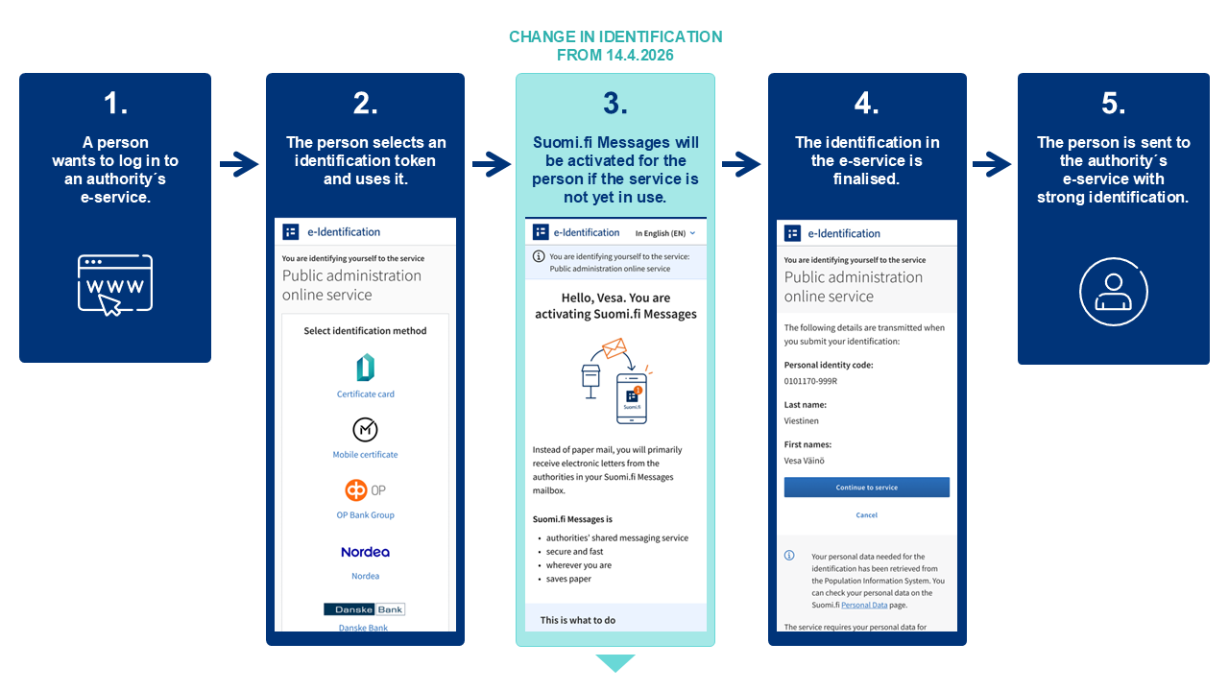
See also this instructional video on activating Suomi.fi Messages: https://dreambroker.com/channel/vyve3x7x/4024dque
How can you access your Suomi.fi Messages inbox?
- You can read messages in the Suomi.fi mobile application or by logging in to the Suomi.fi Web Service and going to “Messages” there.
- You can identify yourself with online banking codes, a mobile certificate or the electronic certificate on an ID card.
- You will be sent a notification to your email whenever a new message arrives in Suomi.fi Messages.
- You will also receive notifications of incoming messages from the Suomi.fi mobile application if you have downloaded the app.
Do you want to keep receiving authorities’ messages as paper mail?
You can choose that letters sent by authorities will continue to be delivered to you by paper mail. If you select the option to receive paper mail, this setting will remain active for at least a year at a time. The next time you to identify yourself in an authority’s e-service after a year has passed, you will be directed to activate Suomi.fi Messages again. If you do not identify yourself in any service, you will continue to receive official mail by paper mail even after the one-year deadline.
What to do to start receiving paper mail again:
- Activate Suomi.fi Messages when you identify yourself in an authority’s web service. You cannot return to receiving paper mail before doing this.
- Go to Suomi.fi Messages at suomi.fi/messages.
- Identify yourself with online banking codes, a mobile certificate or the certificate on an ID card.
- In the menu, go to “Settings” and select “Stop using Suomi.fi Messages”.
If necessary, you can also get help from the Digital and Population Data Services Agency’s customer service (tel. +358 295 000).
If you are using the Suomi.fi mobile application, please remember that
- simply uninstalling the application does not deactivate Suomi.fi Messages
- you must always deactivate the service in the Suomi.fi Messages settings.

For more information, please contact
More information on Suomi.fi Messages: suomi.fi/en/messages
Instructional video: How to activate Suomi.fi Messages during identification: https://dreambroker.com/channel/vyve3x7x/4024dque
More information on Suomi.fi e-Identification: suomi.fi/instructions-and-support/messages/what-is-suomifi-messages
Organisations sending mail to Suomi.fi Messages: suomi.fi/instructions-and-support/messages/organisations-and-services-using-suomifi-messages
How to stop using Suomi.fi Messages: suomi.fi/instructions-and-support/messages/use-of-messages/stop-using-messages
What is Suomi.fi Messages?
Suomi.fi Messages is a secure electronic mailbox that replaces official paper mail. The service is used by several authorities, and its use is constantly increasing. Incoming messages can be read using the Suomi.fi mobile application or by logging in to the Suomi.fi Web Service at suomi.fi. This way, you can read incoming mail wherever you are.
You can activate Suomi.fi Messages by downloading the Suomi.fi mobile application or by logging in at suomi.fi/messages. You can identify yourself with online banking codes, a mobile certificate or the electronic certificate on an ID card. When you activate Suomi.fi Messages, you will receive mail from several different authorities electronically as well.
Notifications of new messages are sent to the email address that you provide to the service. Users of the Suomi.fi mobile application will also receive notifications directly through the app.
In March 2026, there were already 2.6 million users of Suomi.fi Messages.
Additional information about Suomi.fi Messages: suomi.fi/instructions-and-support/messages

What does the transition to digital communication with authorities mean?
Legislation on the primacy of digital official mail enters into force on 14 April 2026. After that, official mail will primarily be delivered digitally to everyone who uses electronic services. Adults who log into authorities’ e-services are directed to activate Suomi.fi Messages during the identification process if they are not already using the service.
People who do not use digital services will continue to receive their official mail on paper, unless they choose otherwise. It is also possible to opt out of receiving electronic messages, after which messages will once again be sent by paper mail. If a person who has opted for paper mail continues using e-services, they will be directed to activate Suomi.fi Messages again the next time they identify themselves in an authority’s e-service after 365 days have passed.
The transition to digital mail will bring significant benefits. This will save tens of millions of euros per year for society and make everyday life easier for citizens. Letters sent by authorities will be available faster than before, found in one place and always available.
Once the legislation enters into force, official mail will primarily be delivered in Suomi.fi Messages to everyone who uses electronic services. In addition to Suomi.fi Messages, citizens may still receive official mail in other digital channels if any have been activated.
Later in 2026, we intend to make it possible to select another digital mail service for receiving official mail, as long as it meets the security and other requirements for official communication. Legislative and technical amendments required for freedom of choice are currently being prepared.
Read more: dvv.fi/en/digital-first-project

