Tiedotepohja julkisen hallinnon organisaatioiden käyttöön:
Transition to digital official mail:
In 2026, you will receive a digital mailbox when you identify in a public authority’s electronic service.
During the first half of 2026, official mail will transition to be primarily digital. The change happens when legislation on the digital priority of official mail comes into force. After the change has come into force, when you identify in [enter your organisation or e-service name here] or another authority’s electronic service for the first time, you will be given a digital mailbox in Suomi.fi Messages. That is where you will receive official mail from several public authorities. Suomi.fi Messages will replace official paper mail: you will not receive letters about the same matter later.
What this change aims for is to encourage people to start primarily using digital official mail. The use of Suomi.fi Messages saves time for both citizens and the authorities when the messages are sent quickly and securely to the right recipient.
Suomi.fi Messages already has over 2 million users. The service is already suggested for you when you identify in a public authority’s electronic service. After the new legislation has come into force during the first half of 2026, your separate consent is no longer required; instead, you will receive a notification of the activation of Suomi.fi Messages when you identify in the service. After this change, Suomi.fi Messages have more than four million users.
How and for whom will Suomi.fi Messages activate?
- Suomi.fi Messages will activate for you if you are an adult and have not yet activated the service.
- You will be given a notification of its activation when you use strong identification in a public administration e-service, i.e. use Suomi.fi e-Identification to sign in.
- Enter your email address upon activation and verify it within one hour. This way, you will always receive an email notification when you receive new mail in Suomi.fi Messages.
- After you have entered your email address, you can continue to identify normally and move to the e-service you were about to use.
- Please note that if you are acting on behalf of an organisation or another person, Suomi.fi Messages will be activated for you personally – not the person or organisation you are acting on behalf of.
If you never use strong identification in a public administration e-service, you will continue to receive official paper mail.
Neither does this change apply to minors nor persons under guardianship or
with a valid continuing power of attorney.
Illustration of the Suomi.fi Messages activation process is presented during strong identification in a public administration e-service in the first half of 2026 after the legislation on the digital priority of official mail has come into force:
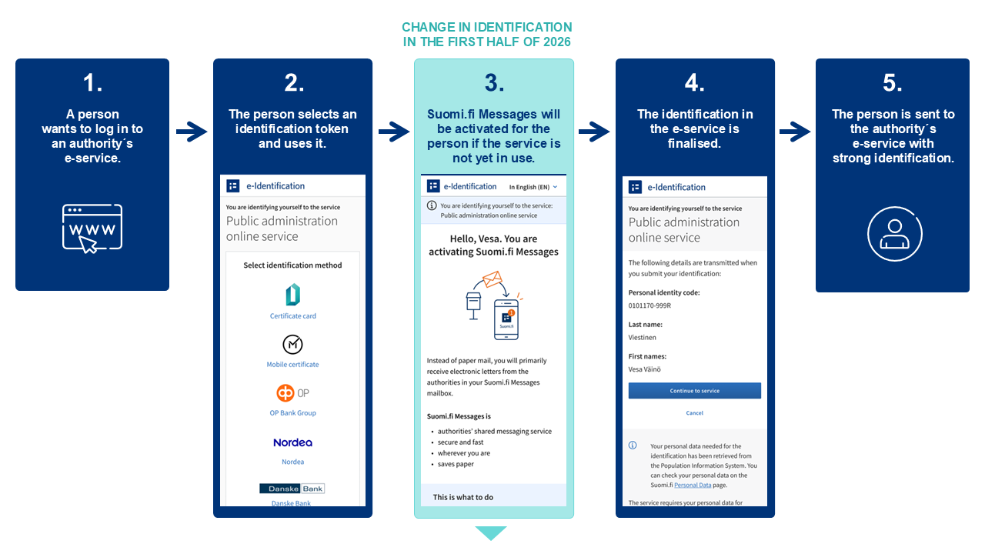
How do I read my Suomi.fi Messages inbox?
- You can read the official messages received in Suomi.fi Messages in the Suomi.fi mobile application or by logging in to the Suomi.fi Web Service and going to "Messages" there.
- Identification takes place with online banking codes, a mobile certificate or the electronic certificate on an ID card.
- You will be sent a notification to your email whenever a new message arrives in Suomi.fi Messages.
- You will also receive notifications of incoming messages in the Suomi.fi mobile app if you have downloaded the app.
You can activate Suomi.fi Messages at https://suomi.fi/messages or by downloading the Suomi.fi mobile application.
What if I want to keep receiving official messages as paper mail?
Transition to digital official mail does not mean that no one can receive official paper mail.
- Suomi.fi Messages will not activate for you if you refrain from using official e-services. This way, you will continue to receive official messages as paper mail.
- This change does not apply to minors or persons under guardianship.
- Neither will all official mail be digital, as some public authorities may use other digital channels for electronic communication. Each organisation’s service will make a note of them.
If you do not want to receive official mail in Suomi.fi Messages, you can opt out of digital messages and return to receiving paper mail in the service settings or by contacting the Digital and Population Data Services Agency’s customer service. You can only make this change after the Suomi.fi Messages have been activated in 2026, not in advance.
This option will remain active for six months at a time. If, after six months have passed, you identify again in a public authority’s e-service, Suomi.fi Messages will re-activate.
If you are using the Suomi.fi mobile application, please remember that
- simply uninstalling the application does not deactivate Suomi.fi Messages.
- you must always deactivate the service in the Suomi.fi Messages settings.
If you wish, you can always re-activate Suomi.fi Messages by downloading the Suomi.fi mobile application or activating the service at suomi.fi/messages.
Further information
More information on Suomi.fi Messages: https://www.suomi.fi/messages
Further information on Suomi.fi e-Identification: https://www.suomi.fi/instructions-and-support/identification/what-is-suomifi-e-identification
Organisations that use Suomi.fi Messages: https://www.suomi.fi/instructions-and-support/messages/organisations-and-services-using-suomifi-messages
How to stop using Suomi.fi Messages: https://www.suomi.fi/instructions-and-support/messages/use-of-messages/stop-using-messages
What is Suomi.fi Messages?
Suomi.fi Messages is a secure digital mailbox that replaces official paper mail. The service is used by several authorities, and its use is constantly increasing. Incoming messages can be read using the Suomi.fi mobile application or by logging in to the Suomi.fi Web Service at https://suomi.fi. This way, you can read incoming mail wherever you are.
You can access Suomi.fi Messages by downloading the Suomi.fi mobile application or by logging in at https://suomi.fi/messages. Identification takes place with online banking codes, a mobile certificate or the electronic certificate on an ID card. By activating Suomi.fi Messages, you will also receive mail from various authorities electronically.
Notifications of incoming messages are sent to the email address that you have provided to the service. Users of the Suomi.fi mobile application will also receive notifications directly through the app.
In October 2025, there are already 2.2 million users of Suomi.fi Messages.
More information on Suomi.fi Messages: https://www.suomi.fi/instructions-and-support/messages

What does the transition to digital communication with authorities mean?
Finland will gradually move towards digital communications with the authorities. In 2026, when legislation on the digital priority of official mail comes into force, official mail will mainly be delivered digitally to everyone who uses electronic services. Suomi.fi Messages is automatically activated for adults who log into the authorities’ electronic services with Suomi.fi e-Identification, if they aren’t already a user.
Those who cannot use digital services will continue to receive official mail on paper, unless they choose otherwise. It is also possible to opt out of receiving digital messages with a simple notification, after which messages will once again be sent by paper mail. If a person who has selected paper mail continues to use the e-services, a digital mailbox will be created again for them after six months in Suomi.fi Messages.
The transition to digital communication will bring significant benefits. This will save tens of millions of euros per year for society and make everyday life easier for citizens. Official mail will be available faster than before, can be found in one place and always be available.
After the new legislation has come into force, official mail will mainly be delivered in Suomi.fi Messages to everyone who uses electronic services. In addition to Suomi.fi Messages, citizens may still receive official mail in other digital channels if any have been activated.
Later in 2026, we intend to make it possible to select another digital mail service for receiving official mail, as long as it meets the security and other requirements for official communications. The freedom of choice requires legislation and technical development, which are only just beginning.
Read more: https://dvv.fi/en/digital-first-project

