Newsletter on the activation request for organisations: spring 25
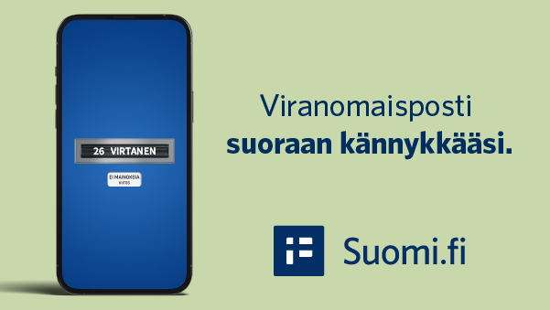
[Hero image size: 600 x 338 px]
New! You can activate Suomi.fi Messages in connection with identification
Important messages straight to your pocket, wherever you go. This is Suomi.fi Messages in a nutshell, a secure electronic mailbox that replaces official paper mail.
Would you like to receive messages from [organisation name here] directly to your mobile device instead of by paper mail? This is now possible with Suomi.fi Messages! ✅
Finland is moving towards digital communication with the authorities. Starting 12 May 2025, you will be prompted to activate Suomi.fi Messages when you identify yourself in the authorities' online services.
In addition to [the organisation's own service], these include MyTax and Traficom's My e-Services, for example.

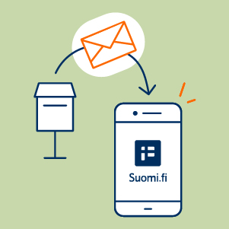
[Image option for text below. Size 300 x 300 px]
Choose whether to activate Suomi.fi Messages
From 12 May 2025, you will be asked to activate electronic messages when logging into the authorities' online services. If you approve the activation, your official mail will be sent by default to Suomi.fi Messages.
To activate electronic messages, you must provide your e-mail address and confirm it with a code sent to your e-mail.
In the activation request in spring 2025, Suomi.fi Messages will not be automatically enabled for you without your consent. You can also skip the activation. You will not see the question if you have already activated Suomi.fi Messages.
(Button: Read more about Suomi.fi Messages)


[Image option for text below. Size 300 x 300 px]
Suomi.fi Messages: your electronic mailbox
Suomi.fi Messages is a secure electronic mailbox that replaces official paper mail. The service is used by several authorities, and its use is constantly increasing. ✉️
The transition to electronic communications with authorities will save tens of millions of euros in public funds per year from 2026 onwards.
It allows citizens to receive mail from authorities quickly and easily in the right place: official mail can be easily found in one place and is always available.
You can read the messages in the Suomi.fi mobile application or in a browser by identifying yourself in the Suomi.fi Web Service at suomi.fi/messages.

(Button: Activate Suomi.fi Messages)

